1. **Introduction to MS Excel**

**MS-EXCEL**is a part of Microsoft Office suite software. It is an electronic spreadsheet with numerous rows and columns, used for organizing data, graphically representing data(s), and performing different calculations.

Microsoft Excel is a software application designed for creating tables to input and organize data. It provides a user-friendly way to analyze and work with data. The image below provides a visual representation of what an Excel spreadsheet typically appears

1. **Data validation**

Data validation is a process used to ensure that data entered into a system is accurate, complete, and consistent. It involves defining rules and criteria that data must meet to be considered valid. Data validation can occur at different stages of data processing, including during data entry, data transmission, and data storage.

Here are some common methods and techniques used for data validation:

**Field Validation**: This involves checking individual fields or data elements against predefined criteria. For example, ensuring that an email address field contains a valid email format.

**Range Validation**: Verifying that numerical data falls within a specified range. For instance, checking that a person's age is between 18 and 100.

**Format Validation**: Ensuring that data follows a specific format or pattern. This can include checking dates, phone numbers, postal codes, etc., for correct formatting.

**Length Validation**: Verifying that data does not exceed a maximum length. This is commonly used for fields such as names, addresses, or descriptions.

**Consistency Checks**: Ensuring that data entered into multiple fields or records is consistent with each other. For example, verifying that a shipping address matches the billing address.

**Referential Integrity**: Checking that data references are valid and refer to existing entities in the system. This is common in relational databases where foreign keys are used to link tables.

**Cross-field Validation**: Validating data across multiple fields to ensure logical consistency. For example, checking that a start date is before an end date.

**Data Type Validation**: Verifying that data is of the expected type (e.g., text, number, date). This prevents errors such as entering text in a numeric field.

1. **Introduction to charts**

Charts are visual representations of data used to communicate information effectively and efficiently. In Excel, there are several types of charts available, each suited to different types of data and visualization needs. Here's an introduction to the main types of charts in Excel:

**Column Chart**: Column charts are used to compare values across different categories by representing data as vertical bars. They are suitable for showing changes over time or comparing different items.

**Bar Chart**: Similar to column charts, bar charts also compare values across categories, but the bars are horizontal instead of vertical. They are useful for displaying data when the categories have long names or when you want to emphasize the magnitude of values.

**Line Chart**: Line charts display data as a series of data points connected by straight lines. They are commonly used to show trends over time and to visualize continuous data.

**Pie Chart**: Pie charts represent data as slices of a circular pie, with each slice representing a proportion of the whole. They are useful for showing the composition of a data set or illustrating proportions.

**Area Chart**: Area charts are similar to line charts, but the area below the lines is filled with color. They are effective for highlighting the magnitude of change over time while also showing the overall trend.

**Scatter Plot**: Scatter plots are used to visualize the relationship between two variables. Each data point is represented by a dot on the chart, with the horizontal axis representing one variable and the vertical axis representing the other.

**Bubble Chart**: Bubble charts are similar to scatter plots but with an additional dimension represented by the size of the data points (bubbles). They are useful for visualizing three-dimensional data sets, with the x-axis, y-axis, and bubble size representing different variables.

**Histogram**: Histograms display the distribution of a continuous data set by dividing the data into bins and representing the frequency or count of data points within each bin as bars. They are helpful for understanding the shape and spread of data.

**Box Plot (Box and Whisker Plot)**: Box plots are used to visualize the distribution of a data set and to identify outliers. They display the median, quartiles, and range of the data, providing a concise summary of its distribution.

1. **pivot table**

A pivot table is a powerful data analysis tool in Excel that allows you to summarize, analyze, and manipulate large datasets with ease. It enables you to extract meaningful insights from your data by organizing and summarizing it into a more manageable format.

Here's a description of how pivot tables work and what they can do:

**Data Summarization**: Pivot tables allow you to summarize large datasets by aggregating and consolidating data based on various criteria. You can quickly calculate sums, counts, averages, minimums, maximums, and other summary statistics for your data.

**Dynamic Data Analysis**: Pivot tables provide dynamic analysis capabilities, allowing you to easily rearrange, filter, and drill down into your data to explore different perspectives and uncover trends or patterns.

**Flexible Data Layout**: You can arrange your data in rows and columns to create customized views of your dataset. Pivot tables allow you to drag and drop fields to pivot, filter, or group your data dynamically, making it easy to customize your analysis based on your specific requirements.

**Grouping and Categorization**: You can group data into categories or intervals using pivot tables, making it easier to analyze and interpret large datasets. This is particularly useful for analyzing time-based data, such as sales by month or quarter.

**Calculations and Formulas**: Pivot tables support the creation of custom calculations and formulas, allowing you to perform complex calculations on your data without modifying the original dataset. You can add calculated fields or items to perform additional analyses and derive new insights.

**Interactive Reporting**: Pivot tables enable interactive reporting by providing features such as drill-down, expand/collapse, and sorting options. This allows users to interactively explore and analyze data to gain deeper insights and make informed decisions.

**Visual Presentation**: Pivot tables offer various formatting and styling options to enhance the visual presentation of your data. You can customize the appearance of your pivot table, including fonts, colors, borders, and themes, to create professional-looking reports and dashboards.

1. **Scenario manager**

It sounds like you're referring to a scenario manager in Excel. A scenario manager is a tool within Excel that allows you to create and manage multiple scenarios for your data. This feature is particularly useful for performing what-if analysis and comparing different sets of input values to see how they affect the outcome.

Here's how you can use the scenario manager in Excel:

**Define Scenarios**: First, you identify the variables in your worksheet that you want to analyze. These variables could be things like sales volumes, pricing levels, production costs, or any other factors that influence your outcomes.

**Create Scenarios**: Once you've identified your variables, you can create different scenarios by specifying different values for each variable. For example, you might create one scenario with optimistic sales projections and another scenario with conservative sales projections.

**Name Scenarios**: Give each scenario a descriptive name to easily distinguish between them. This could be something like "Best Case," "Worst Case," or "Base Case."

**Store Scenarios**: Excel stores these scenarios separately, so you can switch between them to see how each set of input values impacts your results.

**View Summary Reports**: After creating scenarios, you can generate summary reports that show the outcomes of each scenario. These reports typically include key performance indicators or metrics that you're interested in, such as profit margins, net income, or return on investment.

**Compare Scenarios**: With the scenario manager, you can easily compare the results of different scenarios side by side. This allows you to assess the potential risks and opportunities associated with each scenario and make informed decisions based on the analysis.

1. **Protecting data**

Protecting data refers to the process of safeguarding sensitive information from unauthorized access, disclosure, alteration, or destruction. It involves implementing various security measures and practices to ensure that data remains confidential, integral, and available only to authorized users. Here's a description of key aspects of data protection:

**Access Control**: Access control mechanisms are implemented to restrict access to data based on user roles, privileges, or permissions. This involves authentication (verifying the identity of users) and authorization (determining what actions users are allowed to perform).

**Encryption**: Encryption is the process of converting data into a format that cannot be easily understood without the use of a decryption key. It helps protect data confidentiality by making it unreadable to unauthorized parties, even if they gain access to the encrypted data.

**Data Masking**: Data masking involves replacing sensitive data with fictitious, anonymized, or obfuscated values while preserving the format and structure of the original data. It is commonly used to protect sensitive information in non-production environments or when sharing data for testing or analytics purposes.

**Backup and Recovery**: Regular data backups are essential for protecting against data loss due to accidental deletion, hardware failures, or other unforeseen events. Backup copies of data should be securely stored in offsite locations and regularly tested to ensure they can be restored when needed.

**Firewalls and Intrusion Detection Systems (IDS)**: Firewalls and IDS are network security technologies that help protect data by monitoring and controlling incoming and outgoing network traffic. They can detect and block unauthorized access attempts, malware, or other suspicious activities that could compromise data security.

**Data Loss Prevention (DLP)**: DLP solutions are designed to prevent the unauthorized transmission or sharing of sensitive data outside of an organization's network. They use content inspection and policy enforcement to detect and block attempts to exfiltrate sensitive information via email, web uploads, or other channels.

**Security Awareness Training**: Educating employees about data security best practices and policies is crucial for preventing data breaches caused by human error or negligence. Security awareness training programs help raise awareness about common threats, phishing scams, and safe data handling practices.

1. **Introduction to macros.**

Macros are a powerful feature in Excel that allow you to automate repetitive tasks by recording a series of actions and then replaying them with a single click of a button. They are essentially small programs written in a simplified programming language called VBA (Visual Basic for Applications) that can perform various operations on your Excel data.

Here's an introduction to macros and how they work in Excel:

**Recording Macros**: Excel allows you to record a sequence of actions as a macro. You can start recording by going to the "View" tab, clicking on "Macros," and then selecting "Record Macro." Excel will then record every action you perform, such as entering data, formatting cells, or applying formulas.

**Editing Macros**: After recording a macro, you can edit it to customize its behavior or add additional functionality. You can view and edit macros by going to the "View" tab, clicking on "Macros," and selecting "View Macros." This will open the "Macro" dialog box, where you can select the macro you want to edit and click "Edit" to modify its code.

**Running Macros**: Once you have recorded or created a macro, you can run it by going to the "View" tab, clicking on "Macros," and selecting "Run Macro." This will execute the macro, performing the series of actions you recorded or programmed.

**Assigning Macros to Buttons**: You can assign macros to buttons, shapes, or objects in your Excel worksheet to make them easily accessible. Simply right-click on the button, shape, or object, select "Assign Macro," and then choose the macro you want to assign.

**Using Macros for Automation**: Macros are particularly useful for automating repetitive tasks, such as generating reports, formatting data, or performing calculations. By recording or writing macros, you can save time and reduce errors by letting Excel handle these tasks for you.

**Writing Macros in VBA**: For more advanced customization and functionality, you can write macros directly in VBA. VBA is a programming language similar to Visual Basic, and it allows you to create complex macros with conditional logic, loops, variables, and other programming constructs.

**Security Considerations**: Since macros can execute code, they have the potential to pose security risks if they are created by malicious actors. Excel includes security features to protect against harmful macros, such as macro settings that control whether macros are enabled or disabled, and the ability to digitally sign macros to verify their authenticity.

1. **SUMIFS**

SUMIFS is a function in Excel used for summing values in a range based on multiple criteria. It allows you to specify conditions or criteria that must be met for each corresponding cell in a range, and then sum the values that meet all of those conditions.

Here's the syntax of the SUMIFS function:

=SUMIFS(sum_range, criteria_range1, criteria1, [criteria_range2, criteria2], ...)ria_rane1, criteria1, [criteria_range2, criteria2], ...)

**sum_range**: This is the range of cells that you want to sum values from.

**criteria_range1**: This is the range of cells where you want to apply the first criterion.

**criteria1**: This is the criterion or condition that must be met in **criteria_range1**.

**[criteria_range2, criteria2]**: These are optional additional ranges and criteria to apply further conditions to the sum calculation. You can specify up to 127 range/criteria pairs.

1. **SUMPRODUCT**

The SUMPRODUCT function in Excel is a versatile tool used to multiply corresponding elements in arrays or ranges and then sum up those products. It's particularly useful for performing calculations involving multiple arrays or ranges simultaneously.

The syntax of the SUMPRODUCT function is:

**SUMPRODUCT(array1, [array2], [array3], ...)**

**array1**, **array2**, **array3**, etc.: These are the arrays or ranges that you want to multiply and then sum. You can input up to 30 arrays.

1. **VLOOKUP**

Look for the value in the left most column of the table & return the same row value that column num you specify by default table must be sorted in ascending order.

FORMULA OF VLOOKUP

**VLOOKUP(lookup_value, Table_array, col_index_num,[range lookup])**

Arguments used are defined as:

**lookup_value :** This is the lookup value that should be provided by the user and the data you want to look up. This is a mandatory argument.

**table_array :** This is the table where the *lookup_value*and our desired output both exist. VLOOKUP() function uses this *table_array*argument to find the result. This is a mandatory argument.

**col_index_num :** This is the column number of the *table_array*where VLOOKUP() will search for its output. If it gets the result, it returns the specific value.This is also a mandatory argument.

**[range_lookup] :**The user may or may not provide this according to his or her needs. This argument’s value may be **True or False.** If

**‘True’**, it means an approximate match

**‘False’**, it searches for an exact match.

## **How to Use the VLOOKUP Function in Excel**

Step 1: Select a cell

Step 2: Apply Vlookup

Step 3: Double-click the VLOOKUP command

Step 4: Select the cell and Put a comma

Step 5: Mark table Range and Put Comma

Step 6: Type the number of columns, counted from the left

Step 7: Type 1 or 0 and Press Enter

Step 8: Preview Result

1. **XLOOKUP**

XLOOKUP is a powerful function introduced in newer versions of Excel, specifically Excel 365. It's an improved and more versatile replacement for the traditional VLOOKUP and HLOOKUP functions, offering enhanced features and flexibility in searching for and retrieving data from tables or ranges.

Here's an overview of the XLOOKUP function and its syntax:

**XLOOKUP(lookup_value, lookup_array, return_array, [if_not_found], [match_mode], [search_mode])**

**lookup_value**: This is the value you want to search for.

**lookup_array**: This is the array or range where Excel will search for the **lookup_value**.

**return_array**: This is the array or range from which Excel will return a corresponding value.

**[if_not_found]** (optional): This argument specifies the value to return if no match is found. If omitted, Excel will return an #N/A error.

**[match_mode]** (optional): This argument specifies the type of match to perform. Options include:

0 or -1: Exact match (default).

1: Exact match or next smallest item if no exact match is found.

-1: Exact match or next largest item if no exact match is found.

2: Wildcard characters (* and ?) match.

**[search_mode]** (optional): This argument specifies the search mode. Options include:

1: Search first-to-last.

-1: Search last-to-first.

2: Binary search.

**Difference between Vlookup & Xlookup**

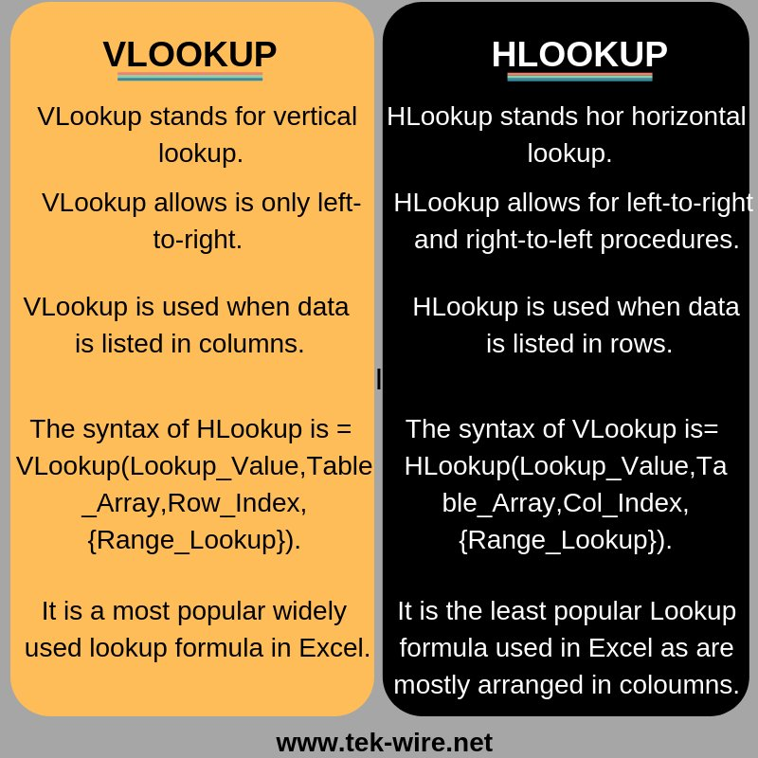

1. **Match - index**

The MATCH and INDEX functions in Excel are often used together to perform powerful lookups and data retrieval operations. Here's a breakdown of each function and how they can be combined:

**MATCH Function:**

The MATCH function, as described earlier, returns the relative position of a specified value within a range of cells.

It's typically used to find the position of a lookup value in a sorted or unsorted array.

=MATCH(lookup_value, lookup_array, [match_type])

**INDEX Function:**

The INDEX function returns the value of a cell in a specified row and column of a range.

It's often used to retrieve specific data points from a table or range based on row and column numbers.

=INDEX(reference, [row], [column])

**Types of error**

**Error #N/A**

It usually occurs when the **Excel lookup functions**like [VLOOKUP](https://www.shiksha.com/online-courses/articles/vlookup-in-excel/), [HLOOKUP](https://www.shiksha.com/online-courses/articles/hlookup-in-excel/), [MATCH](https://www.shiksha.com/online-courses/articles/index-and-match-in-excel/), and [XLOOKUP](https://www.shiksha.com/online-courses/articles/xlookup-in-excel/)cannot find the value you are looking for within the formula in the specified range.

**Error: #VALUE!**

This is one of the most frequent Excel errors, particularly when we enter erroneous data or arguments in our formulas or functions, such as spaces, characters, texts, or formulas requiring numbers.

**Error #REF!**

This type of error in Excel is also one of the most frequent that we can find. It generally occurs when we accidentally delete or replace information about the values ​​that make up an already established function or formula in Excel.

**Error: #NAME?**

A typo in the formula commonly causes this error in Excel or because one or more values ​​entered as arguments in the function cannot be computed.

**Error #DIV/O!**

This error in Excel commonly occurs when the denominator is zero.

**Error #NULL!**

This error occurs when the wrong reference operator is used or not found. Usually, when Excel cannot determine or find the specified range, we get the Excel errors like **#NULL!**

**Error: #NUM!**

Excel error occurs when Excel usually cannot display the result of a mathematical operation. This type of error can occur for two reasons: